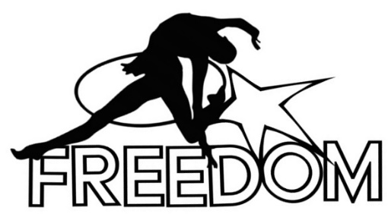

Flexibility classes season 2017-2018

A. Student Information:

Last Name: _____________________First Name: ____________________Middle: __________

Age: _________________DOB: _______________

School Attending: _____________________________________Grade: __________________

Sport or dance school attending: __________________________________________________

Any Health Issues or Allergies:____________________________________________________
Referred by: ____________________________________________________________________

B. Parent or Guardian:

Mother’s information:

Last Name: ______________________First Name: _____________Middle: ________________

Phone#: ____________________________ Email: ____________________________________

Street Address: _____________________________________________________________________

City/Town: __________________________State: _________________Zip: _____________________

Father’s information:

Last Name: ______________________First Name: _____________Middle: ________________

Phone#: ____________________________ Email: ____________________________________

Street Address: _____________________________________________________________________

City/Town: __________________________State: _________________Zip: _____________________
Waiver

I, _____________________________________ (print your name) have chosen to have my child,

__________________________________ (print child’s name), participate in rhythmic gymnastics and dance instruction given by Freedom Rhythmic Gymnastics Academy LLC. I acknowledge that I understand the nature of the activities my child will be participating in and the possibility that despite precautions, accidents and/or physical injury may occur.

I/we agree to release and hold harmless Freedom Rhythmic Gymnastics Academy LLC. including its teachers, and staff members from any cause of action, claims, or demands now and in the future. I/we will not hold Freedom Rhythmic Gymnastics Academy LLC. liable for any personal injury or any personal property damage or loss, which may occur on the premises before, during or after classes or which may occur at any Freedom Rhythmic Gymnastics Academy LLC. sponsored event outside the studio.

I authorize and agree that Freedom Rhythmic Gymnastics Academy LLC. may take and use photographs, videos or likenesses of myself or my child as needed for its record keeping, advertising, social media and/or public relations projects and that I have no rights to the same and will not be compensated for the same.

My signature is proof of my intention to execute a complete and unconditional waiver and release of all liability pursuant to the terms herein, and agreement as to all terms and conditions contained above. I am of lawful age and competent to sign this affirmation.

I HAVE READ THIS DOCUMENT AND UNDERSTAND IT. I FURTHER UNDERSTAND THAT BY SIGNING THIS RELEASE, I VOLUNTARILY SURRENDER CERTAIN LEGAL RIGHTS

Student Name (please print): _____________________________________________________
Parent/Guardian Name (please print): ______________________________________________
Signature______________________________________________Date___________________

Important Information:

Schedule: Sunday 1-2 pm.
Location: “The Pingry School” 50 Country day dr, Short Hills

Dress code: Sportswear, white socks. Hair must be in a bun or high ponytail. No jewelry!
Please bring your own yoga mat.

Food: No food is allowed in the gym. Water only!
Fees: $150/month + $40 one-time registration fee.
Walk-in $40

Sibling discount: 10% two students and 15% three and more students.
Referral bonus: Bring a friend and get $25 off of your next month tuition.
Note: Referral bonus applies only if brought new student enrolled into program (new student should write your name in registration form under referred by).

Make-up classes: Freedom Academy does not guarantee that you can make up missed classes. It is much better that every student attends class each week for continuity and progression. For possibility of make-up please contact the head-coach.

Note: There will be no classes on the following dates:

2017

November 23, 2017 Thanksgiving Day

2018

December 23,24,25 Christmas

December 31-January 1 New Year

March 30 Good Friday

March 31-April 1 Easter

May 13 Mother’s Day

May 27-28 Memorial Day

June 17 Father’s Day

I, ________________________________________________ (Parent name),
parent guardian of__________________________________________________
(Student(s) name) have read, and agree to follow the Rules and Policies of Freedom Rhythmic Gymnastics Academy.

